BASIC PROGRAMMING

JOBSHEET 7

GROUP 7



**GROUP NAME :**

1. **Muhammad Baihaqi Aulia Asy’ari (18_2241720145)**
2. **Maulia Balqis Ansya Aulia (16_2241720246)**
3. **Hawa Esanda (11_2241720079)**

# **2.1 Experiment 1: Loop Review**

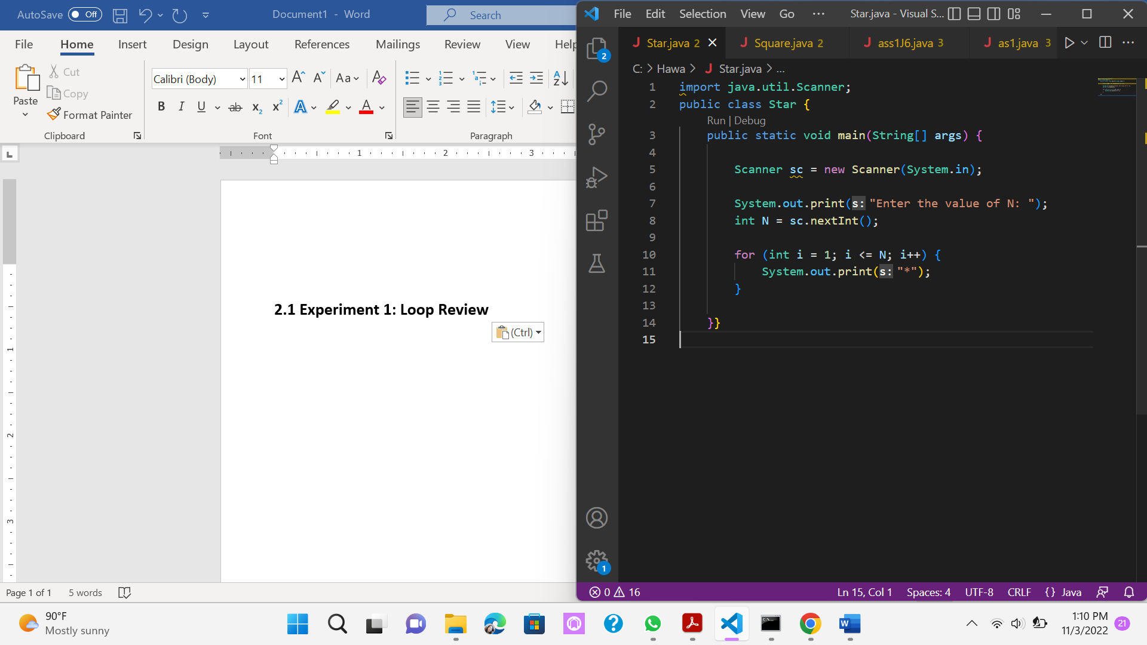

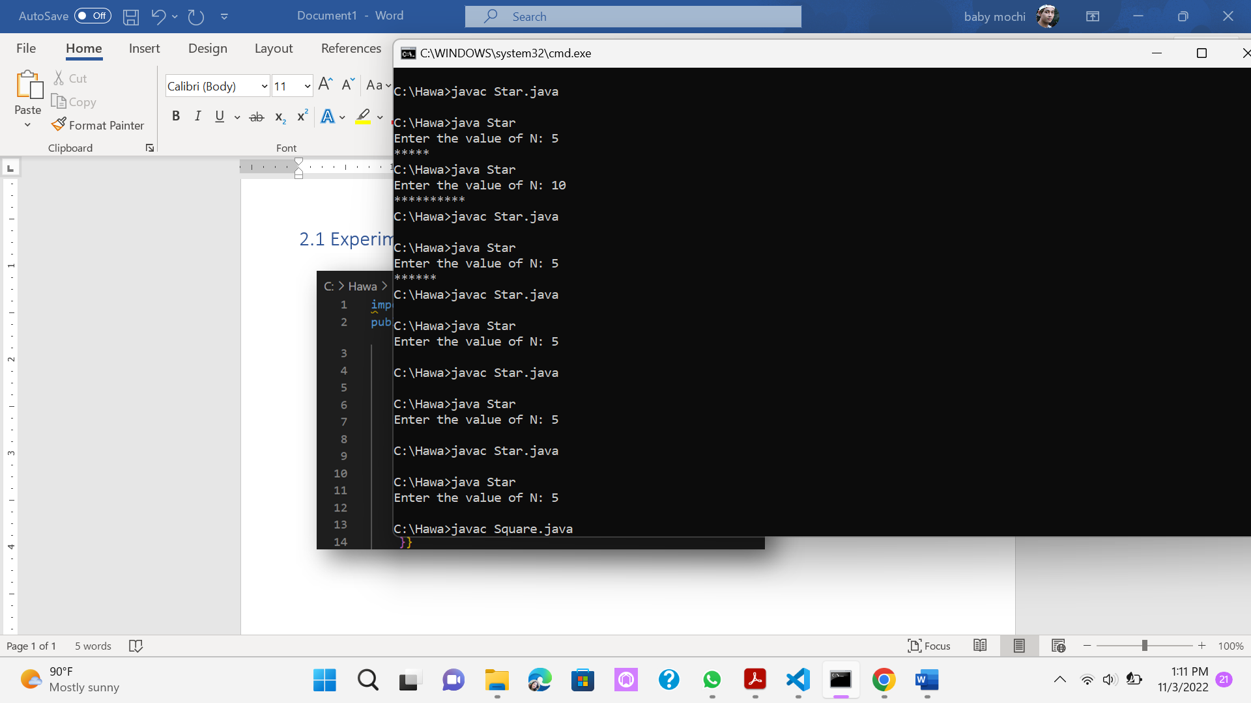

## Questions!

1. If in **for** loop, the initialization **i = 1** is changed to **i = 0**, what is the result? How can It be like that?

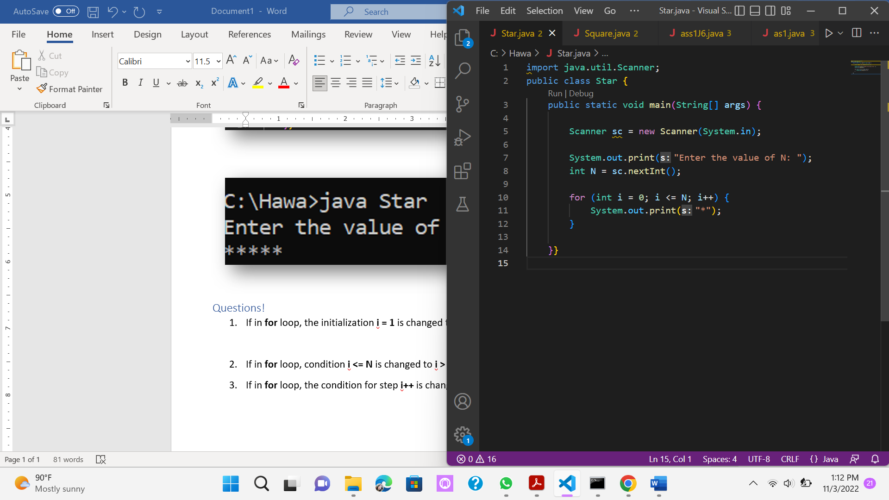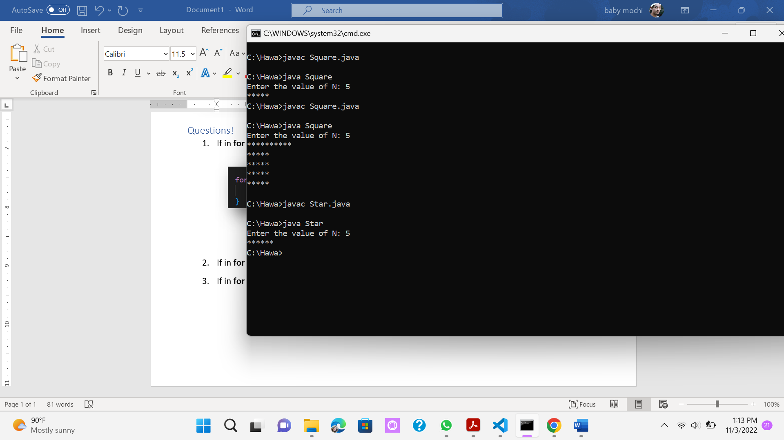

1. If in **for** loop, condition **i <= N** is changed to **i > N**, what is the result? How can It be like that?

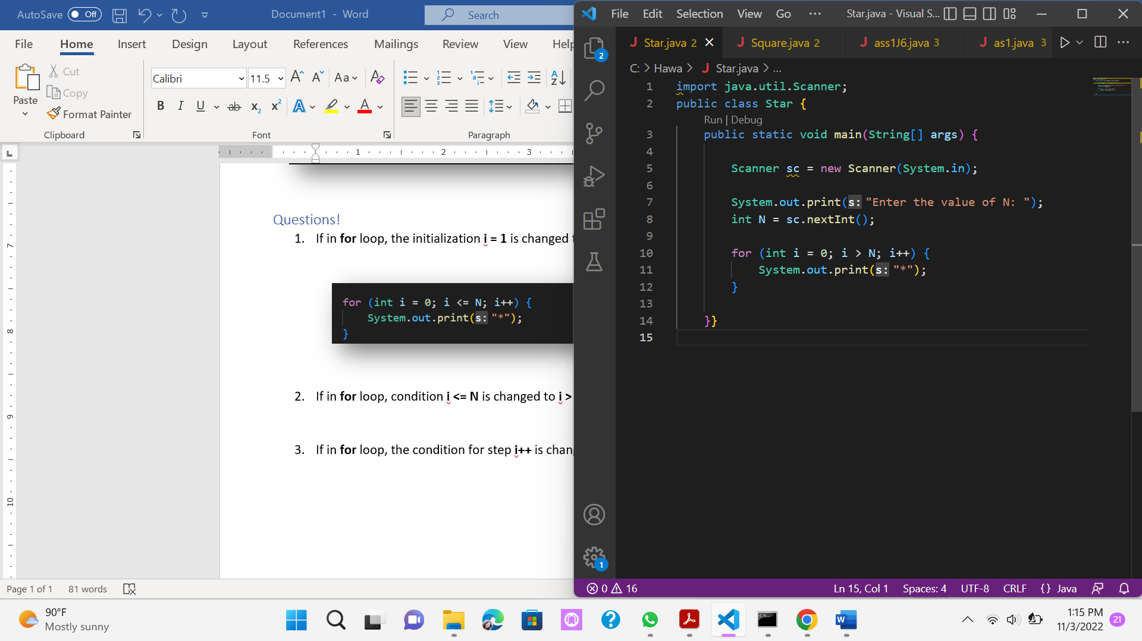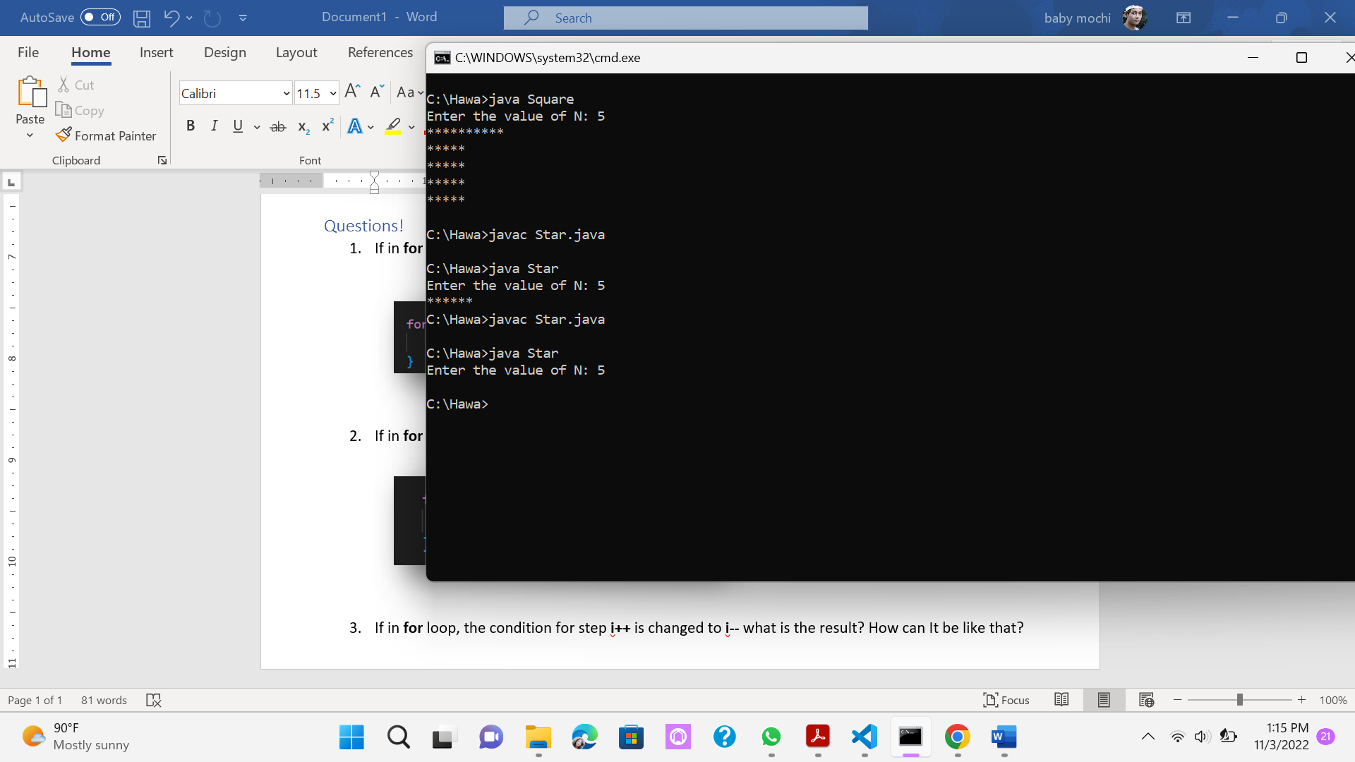

1. If in **for** loop, the condition for step **i++** is changed to **i--** what is the result? How can It be like that?

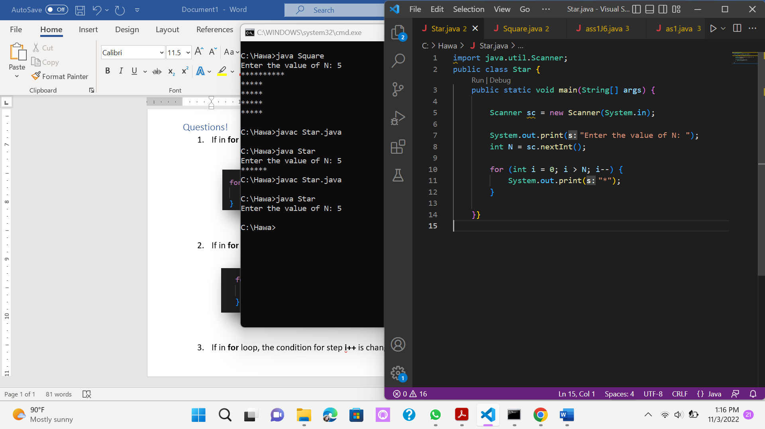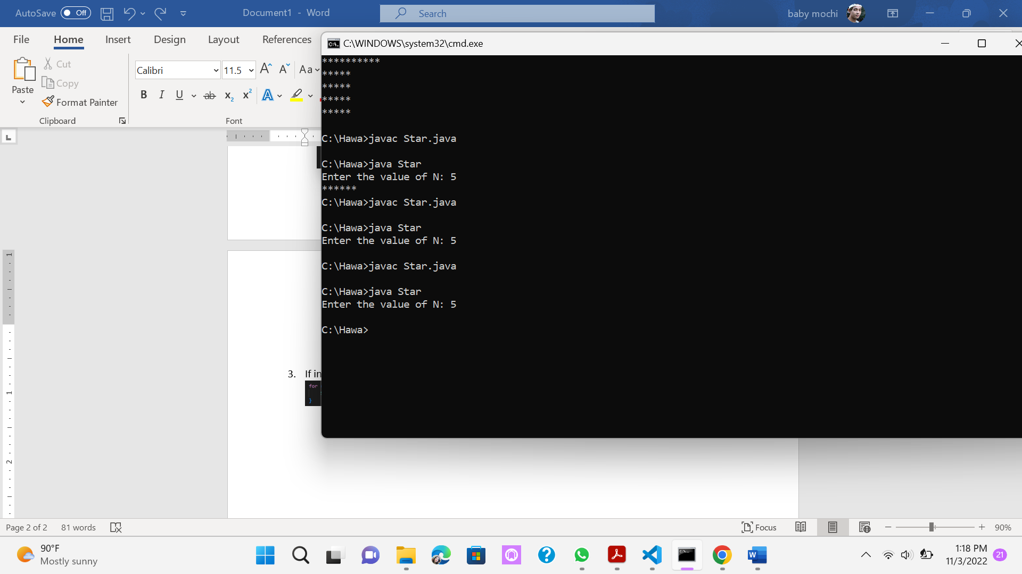

# **2.2 Experiment 2: Square Star**

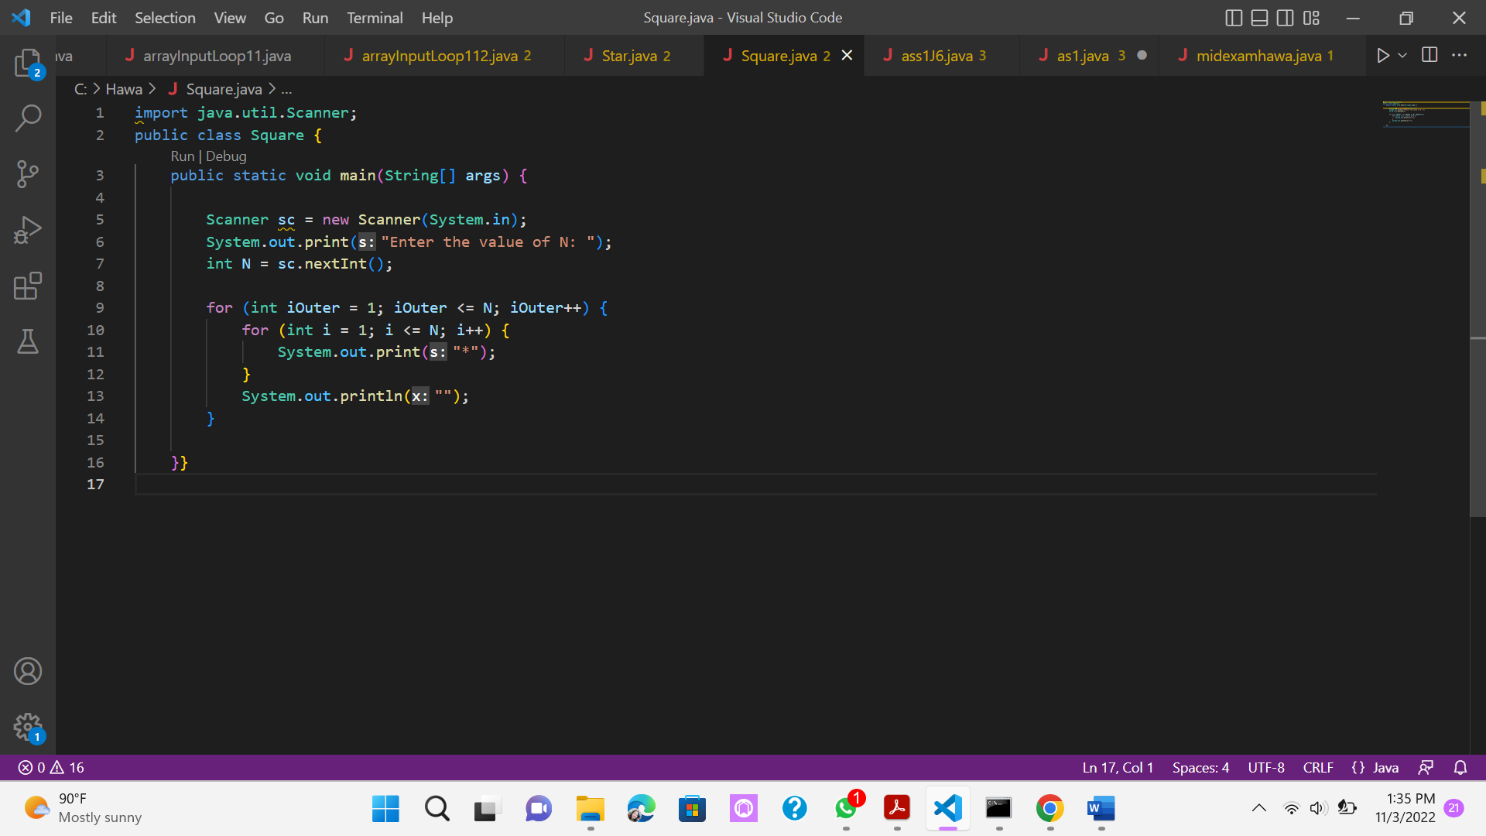

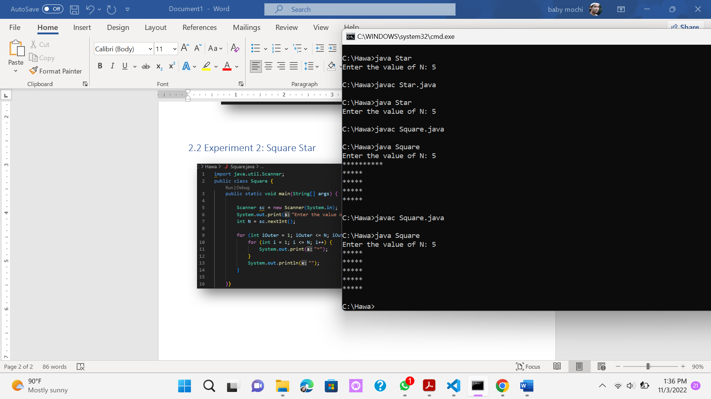

## Questions!

1. Pay attention to outer loop. If in **for** syntax, the initialization **iOuter = 1** is changed to **iOuter = 0**, what is the result? How can it be like that?

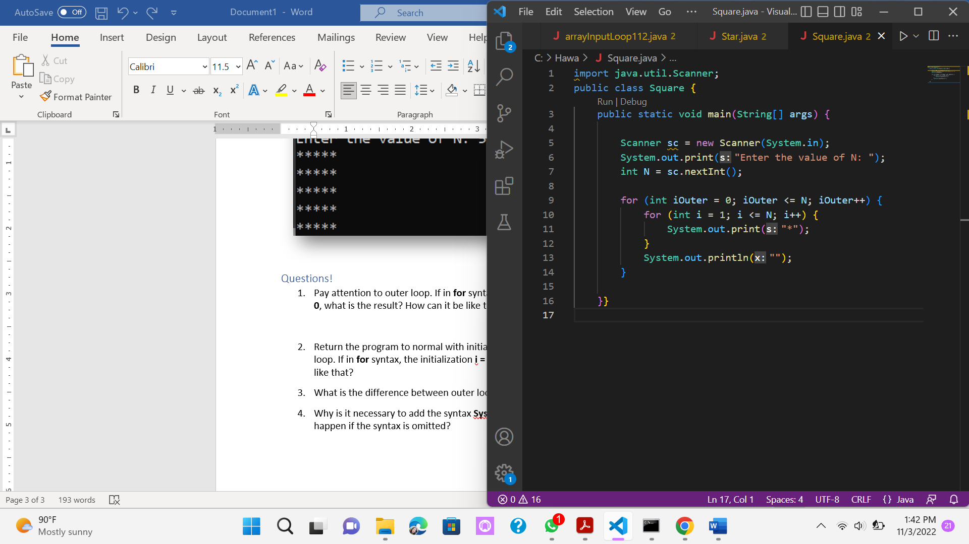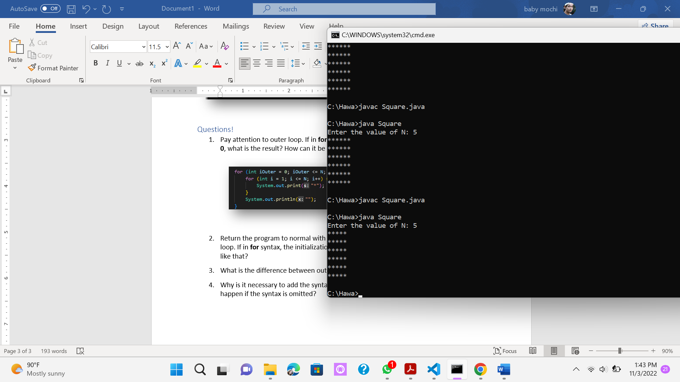

Changing the initialization of iOuter from 1 to 0 would only make the for loop does an extra process adding a new line.

1. Return the program to normal with initialization **iOuter = 1**. Then pay attention to the inner loop. If in **for** syntax, the initialization **i = 1** is changed to **i = 0**, what is the result? How can it be like that?

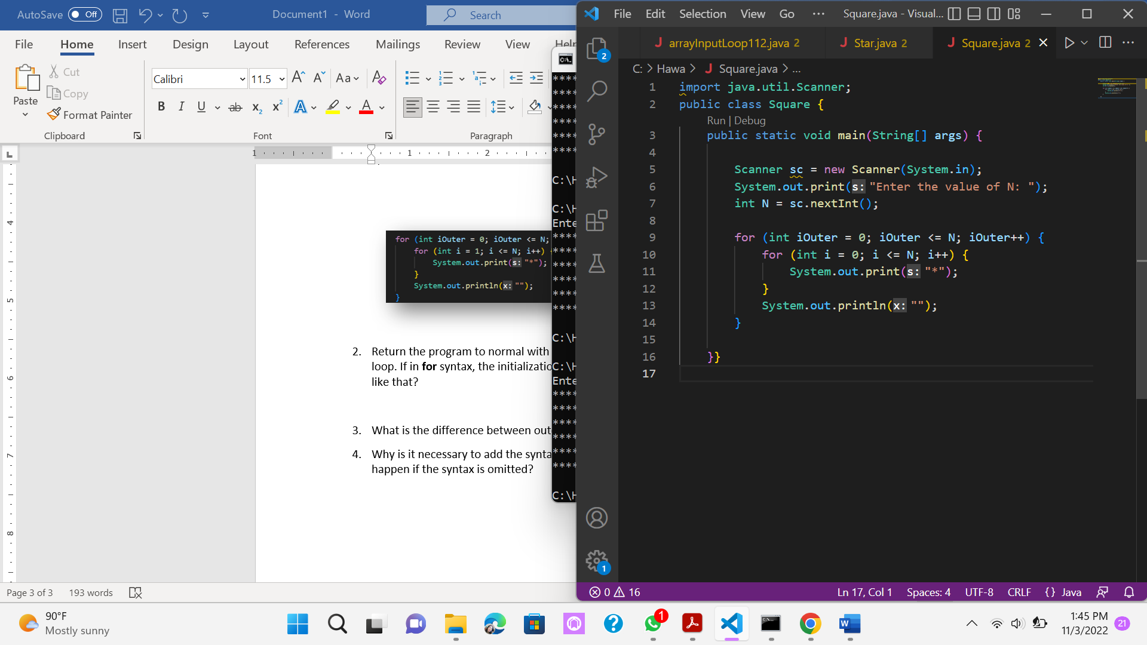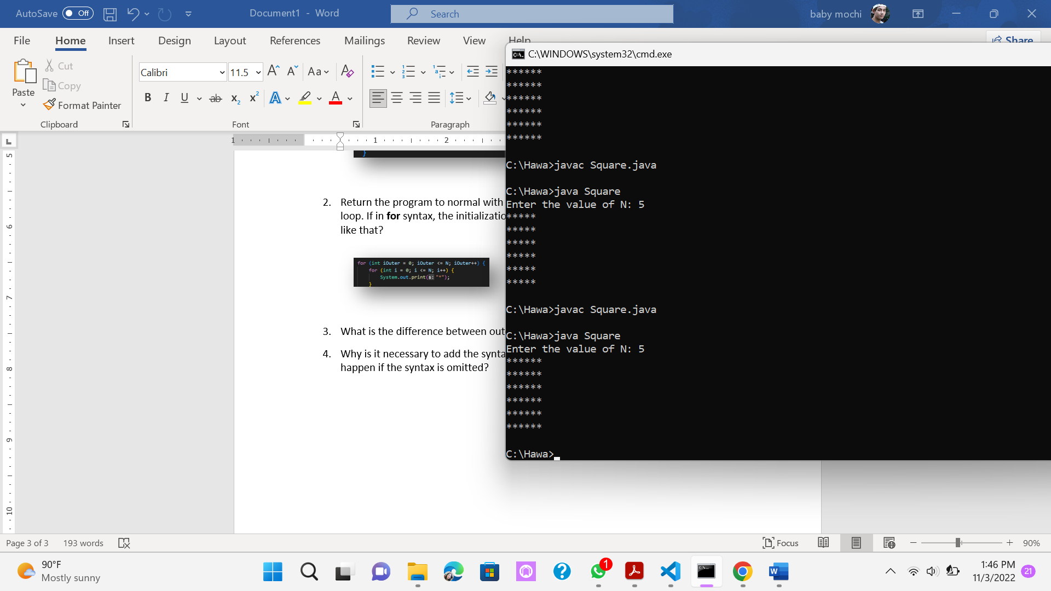

Changing the initialization of i from 1 to 0 would only make the for loop does an extra process adding a new column of stars.

1. What is the difference between outer loop and inner loop?

**Answer :** The inner loop process the repetition of printing stars, while the outer loop process the repetition of printing new line.

1. Why is it necessary to add the syntax **System.out.println();** under inner loop? What will happen if the syntax is omitted?

**Answer :** Because the S.O.P is the one that prints the new line, otherwise it won't print a new line, and the stars would only be printed in a row.

# **2.3 Experiment 3: Triangle Star**

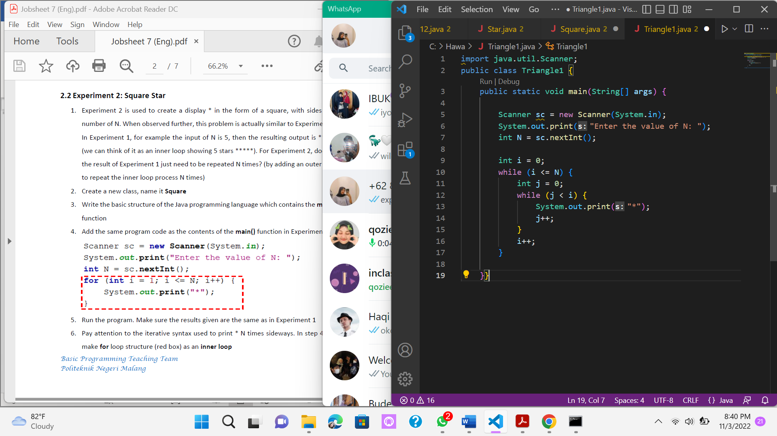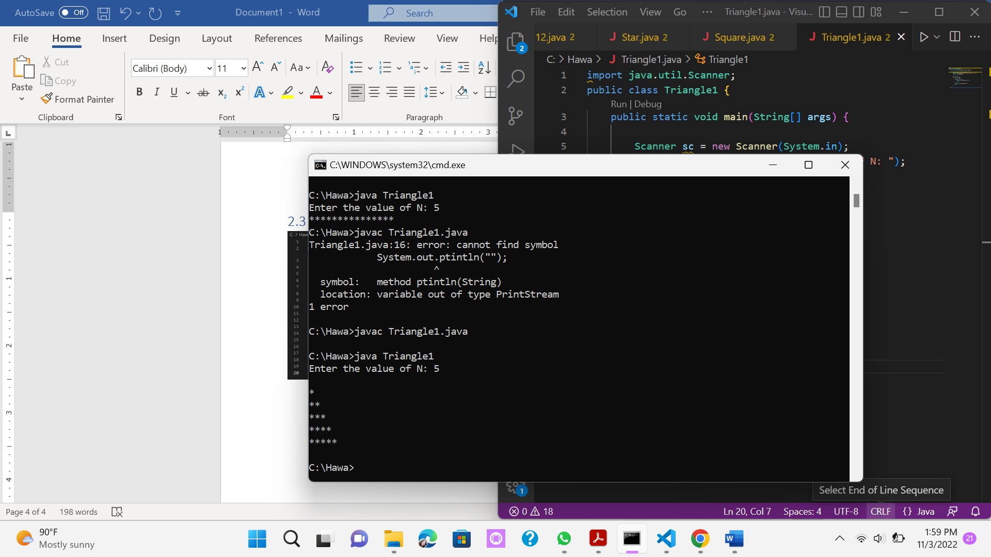

## Questions!

1. Look at the results, is the output generated with a value of N = 5 in accordance with the following display?

**Answer :** No, because if there is no S.O.P then the output '*' becomes a straight line

1. If not, which parts should be improved or added? Describe any parts that need to be improved or added!

Answer : We should added 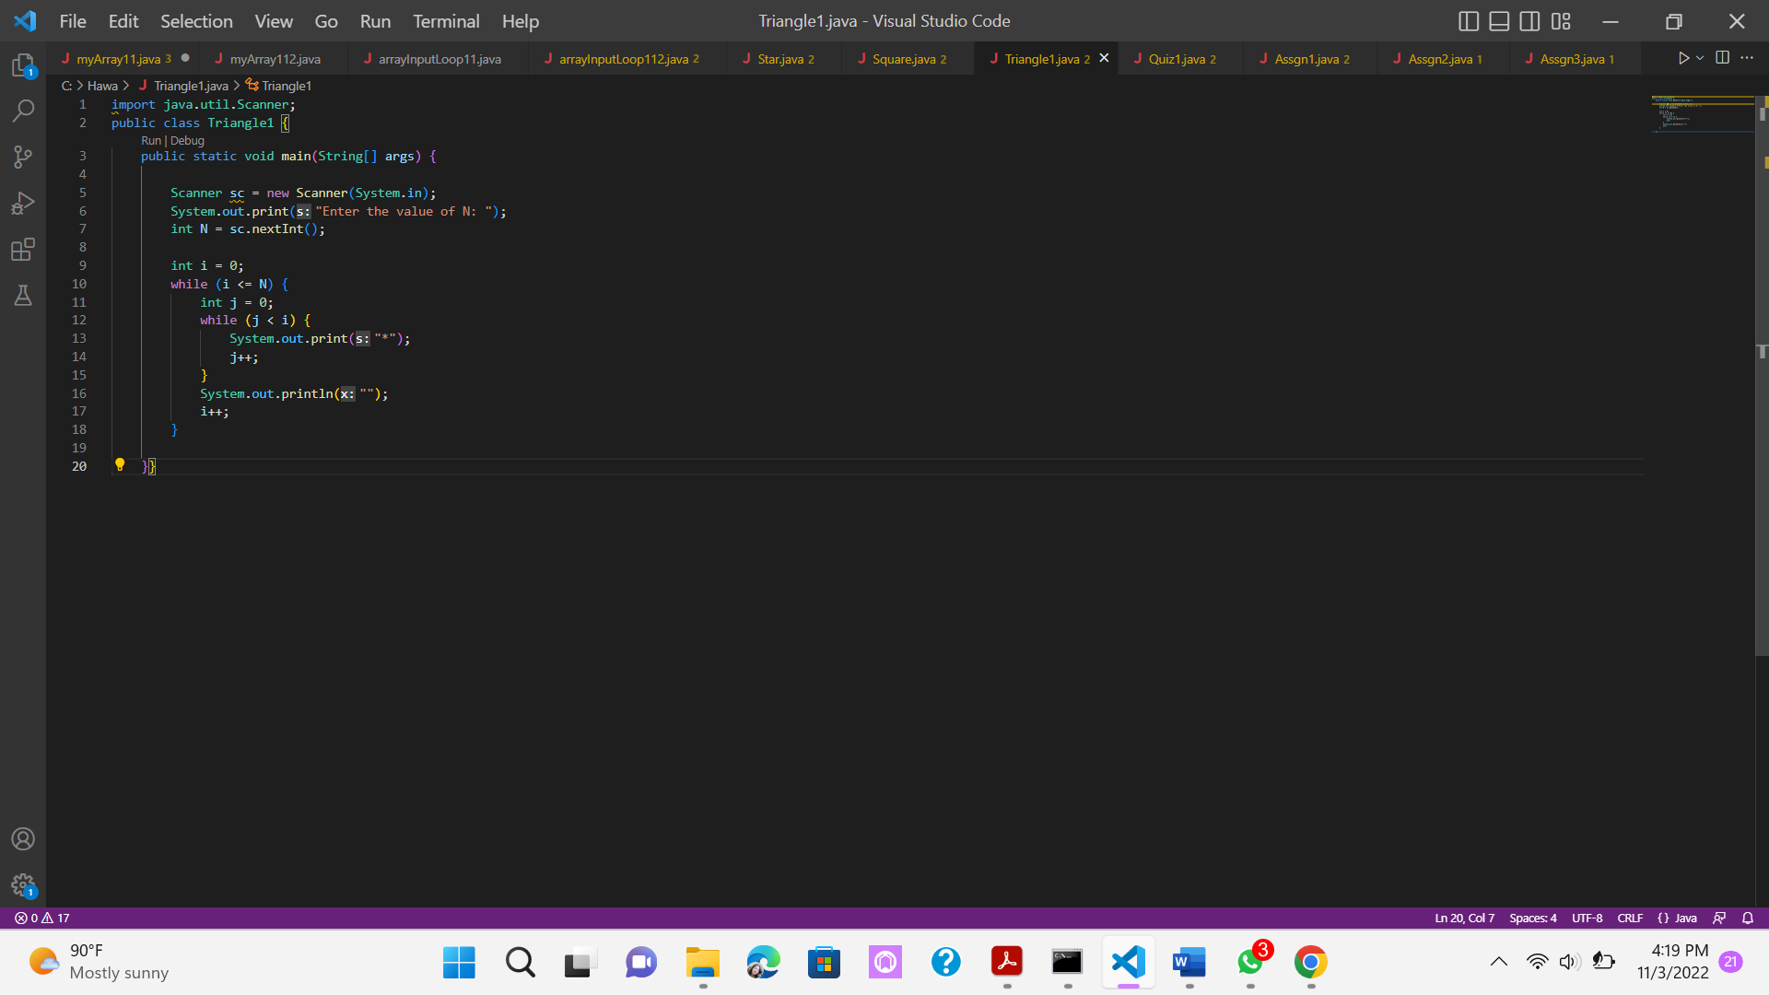 before 

# **2.4 Experiment 4: Guess the Number Quiz**

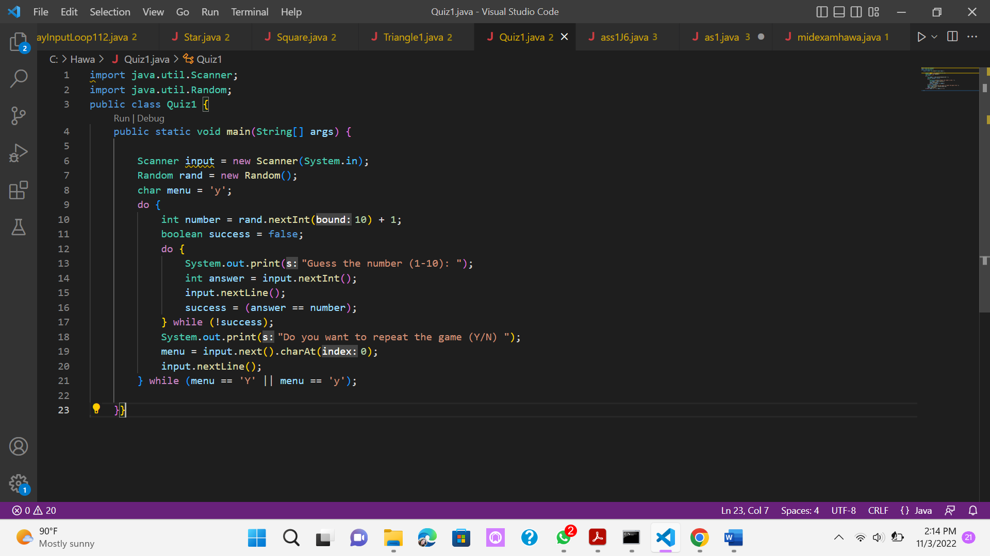

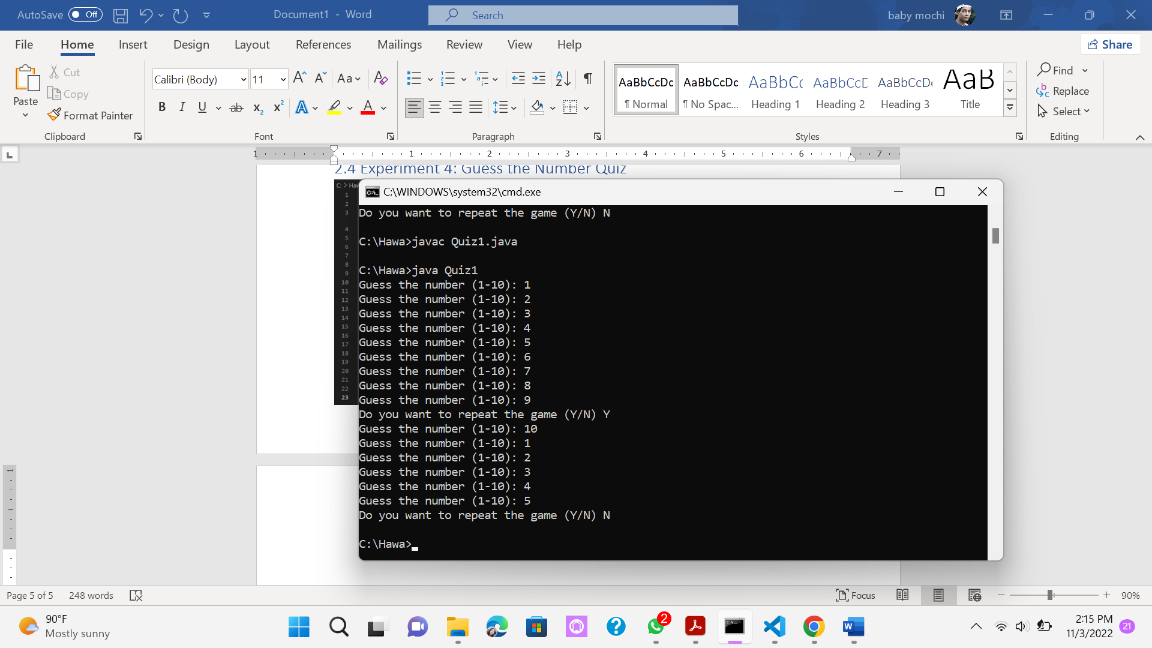

## Questions!

1. Explain the program flow in Experiment 4!

**Answer :** Import the Scanner and Random for input and RNG. declaring a class and p.s.v.m. defining the input and RNG variable. Setting the menu char to 'y' so that the outer do-while condition is met before running the program. Inside the outer do-while loop the integer number is declared with a random number within a range of 1-10. The boolean success is declared as false so that the inner do-while loop condition is met before running th program. The inner do-while loop asked for input to guess the random number and check whether the input number is correct. If it is correct it would break the inner do-while loop. After that, the program asked if the player would want to play again, if the input is 'y' or 'Y' it would loop again from the top, otherwise, it would break the loop and close the program.

1. What must be done to discontinue (not repeat) the game?

**Answer :** Input anything that doesn’t starts with letter y

1. Modify the program above, so that it can display information about: input the guess value entered by the user, whether it is smaller or greater than the answer (number) randomly determined by the computer!

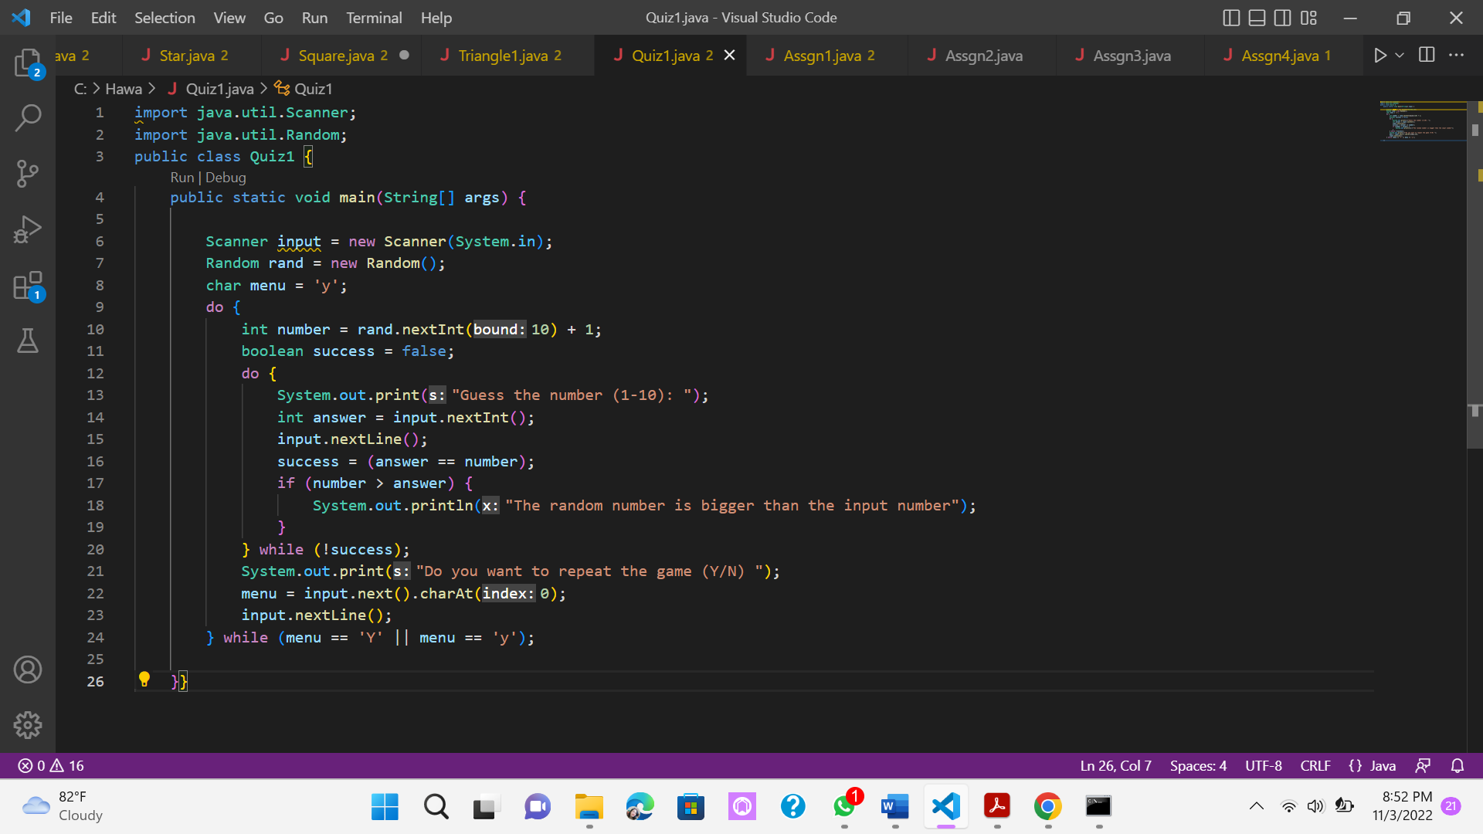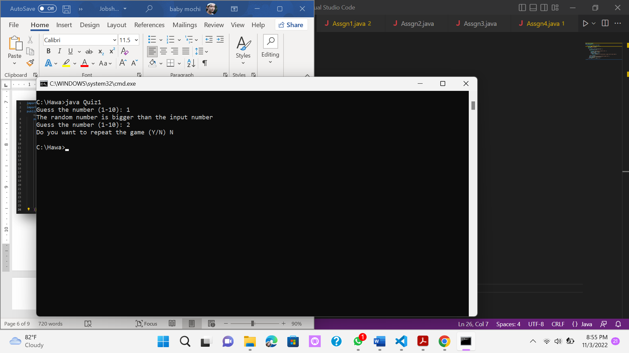

# **3. Assignments**

1. Create a program to print a numeric triangle display as below based on the N input (minimum N value is 3). Example N = 5

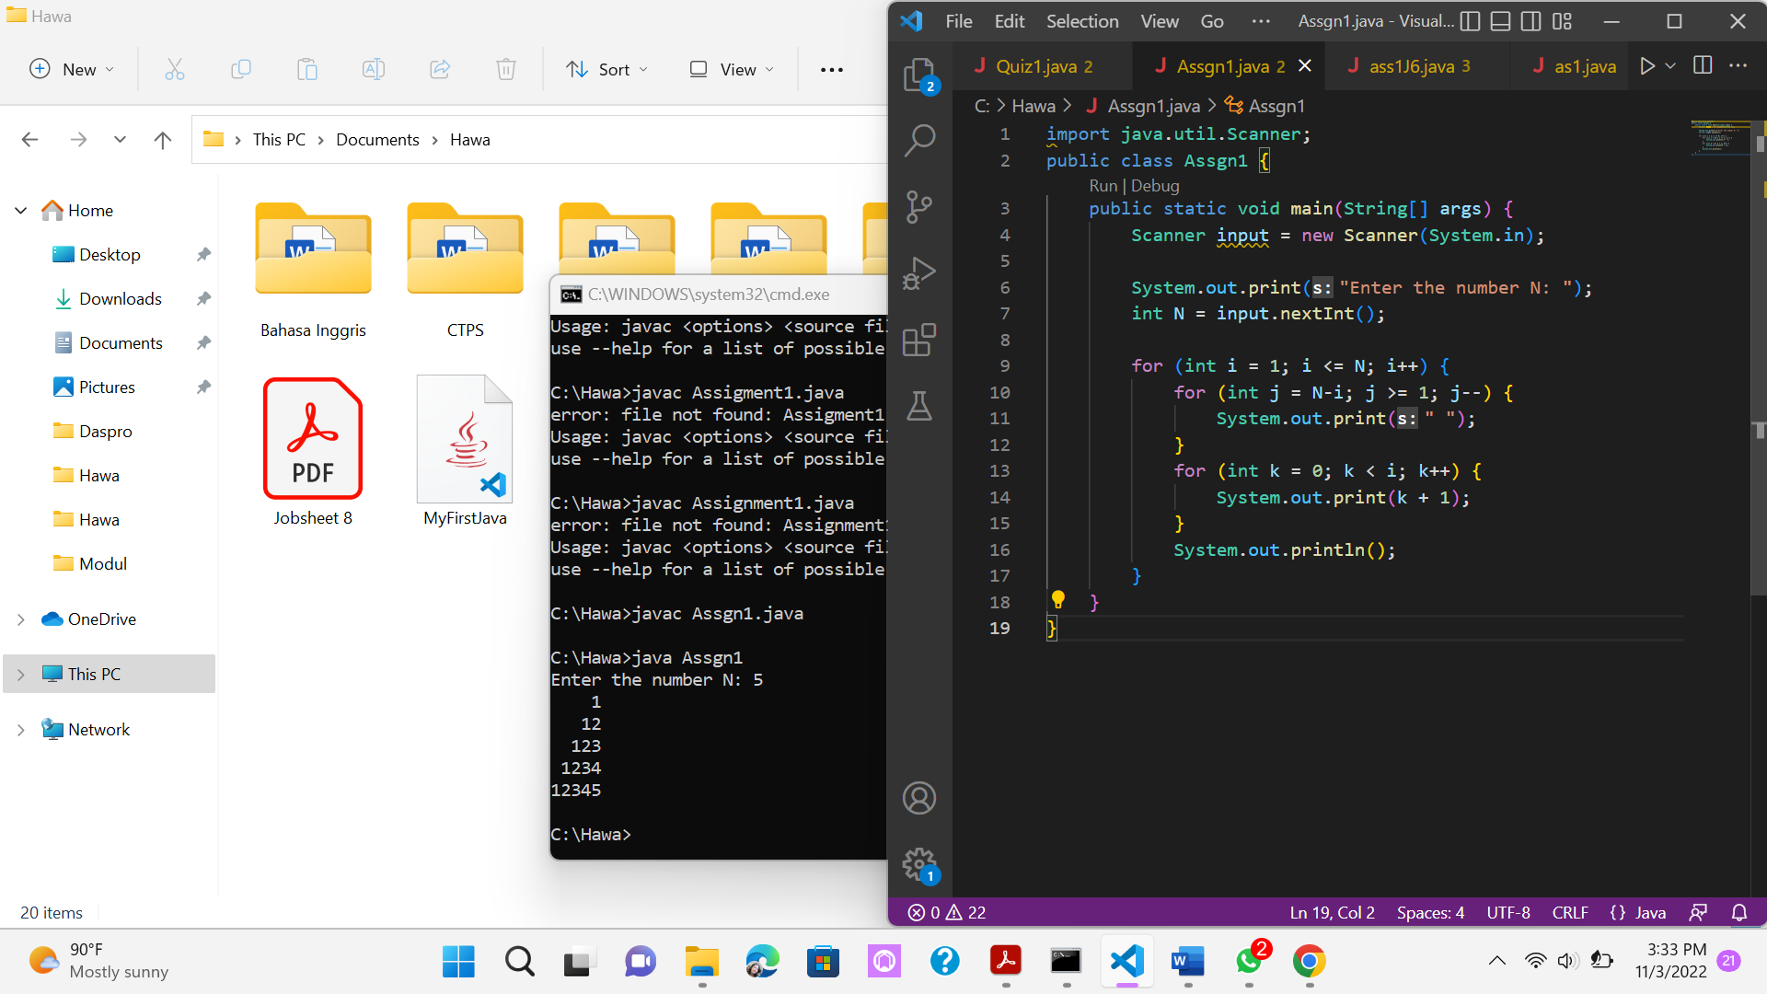 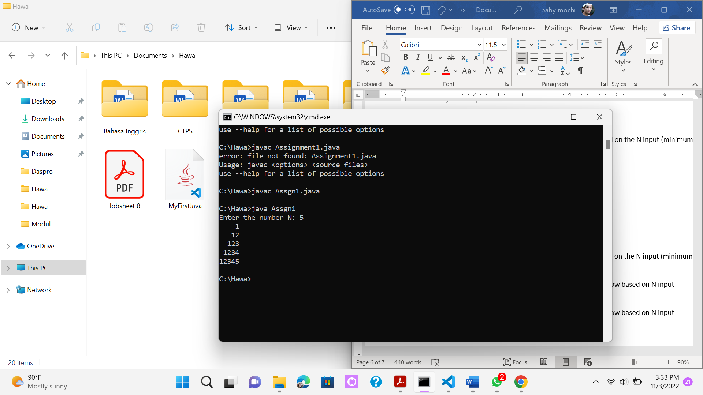

1. Create a program to print the star triangle view shown below based on the N input (minimum N value is 5). Example N = 7

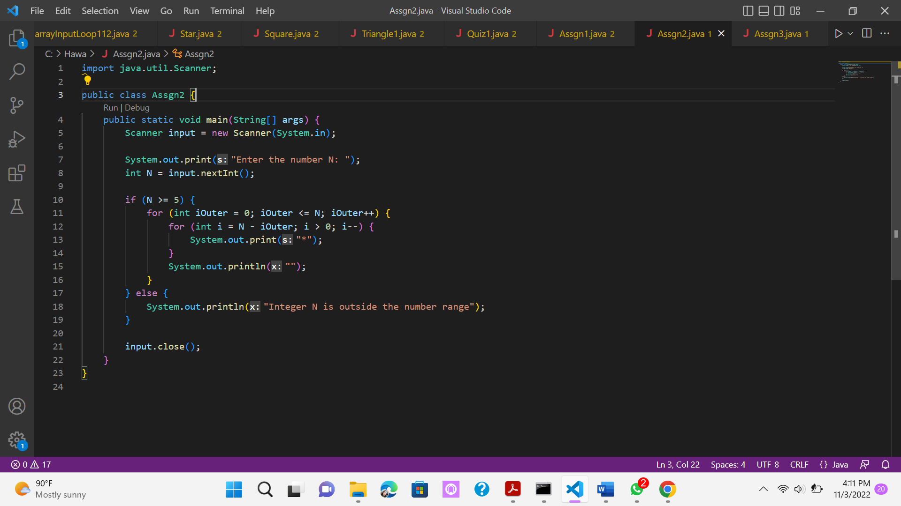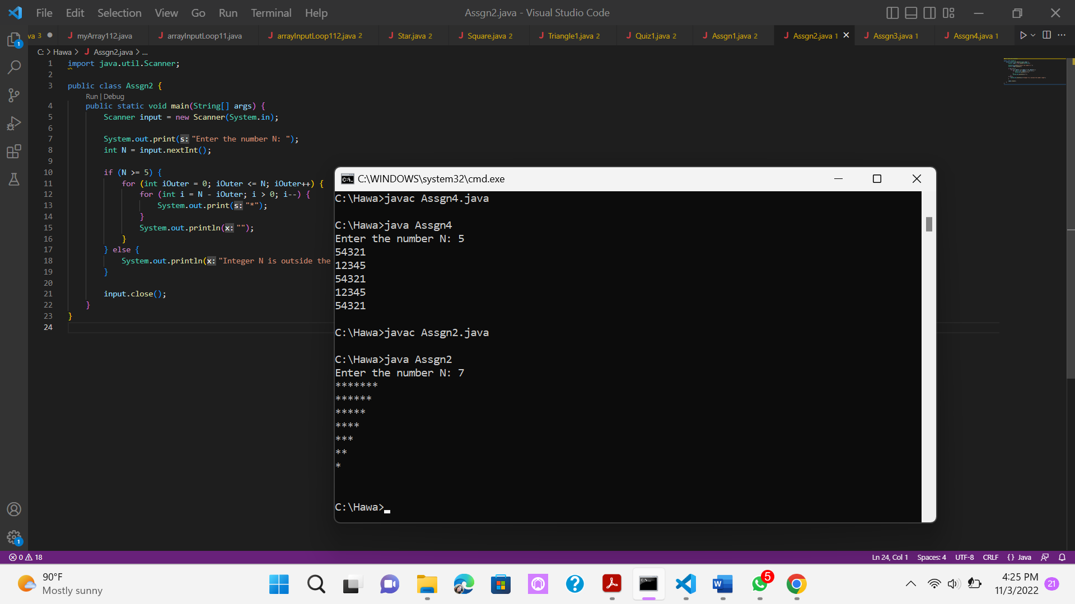

1. Create a program to print a square numeric display like the one below based on N input (minimum N value is 3). Example N = 3 and N = 5

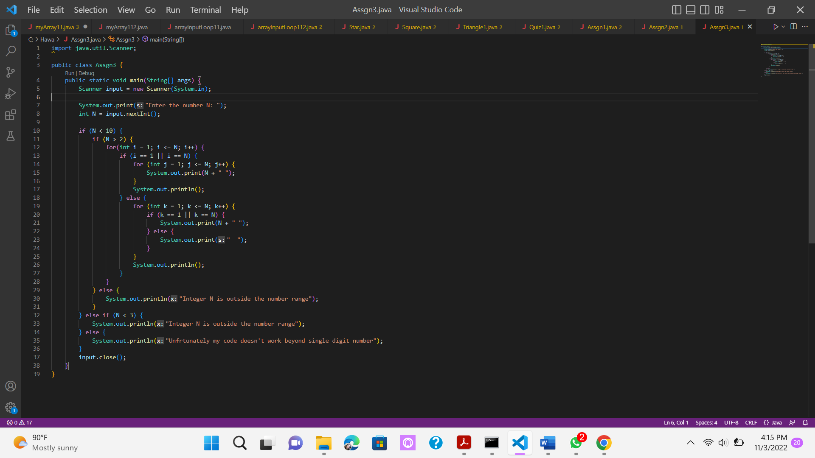

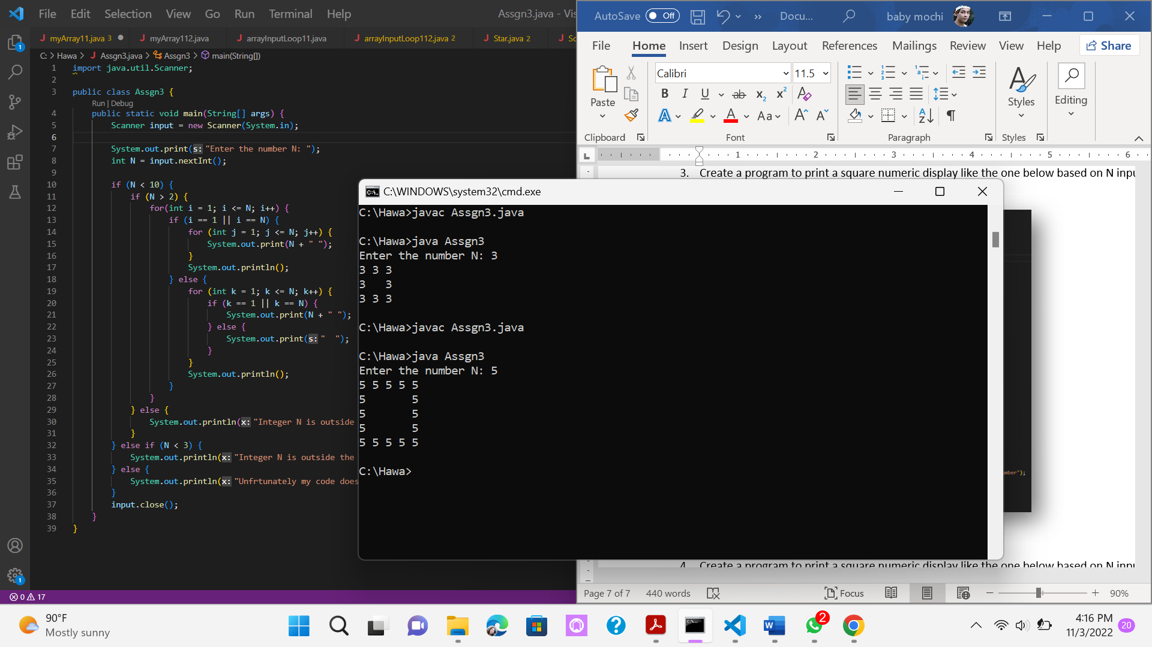

1. Create a program to print a square numeric display like the one below based on N input (minimum N value is 5). Example N = 5

